Winter Session
Wednesdays and Optional Forest Fridays (see below for details!)
Wednesdays- December 4 -February 19 (10 weeks)
9-3p.m. 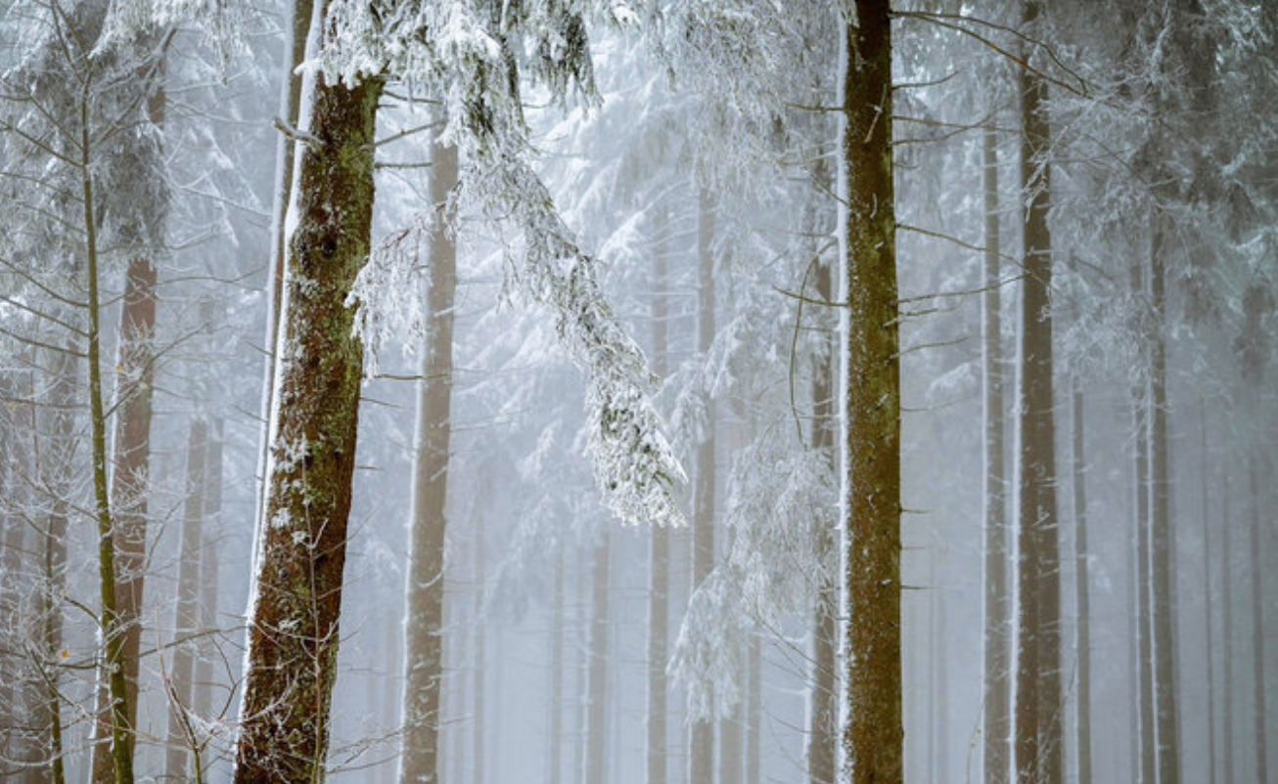

Literacy & Tinker Time Combo- Celebrations!
Boxberry Teachers Cassandra and Deanna will be working with students to read and learn about seasonal celebrations from all over the globe. Students will participate in a variety of activities and craft-making as they explore the wonderful world of winter celebrations from cultures around the world.
Introduction to Printmaking and Bookmaking 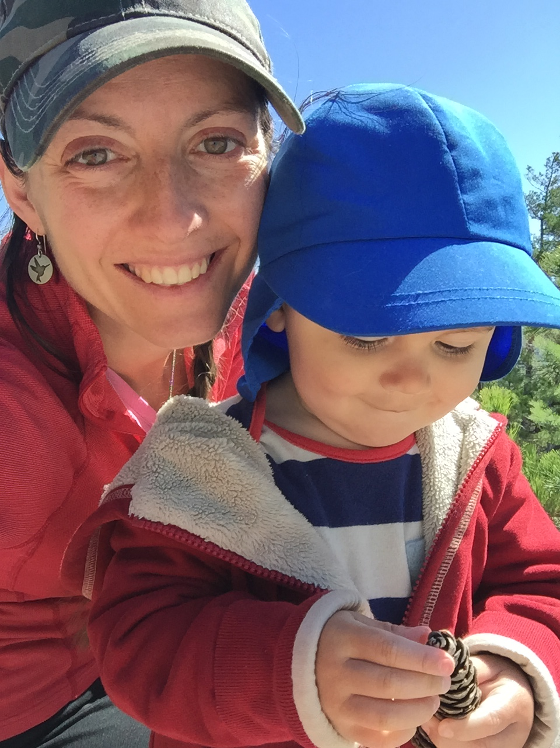
with Local Artist, Kelli Shedd
In this winter session both the Flower room and the Forest room will learn the basics of printmaking including monotypes, collographs, and block printing. A variety of natural and recycled materials will be used to create different textures and images which will culminate with each child making a print block unique to their own ideas and experiences in the class. This block will be printed by each student multiple times in order to create a trade-folio that will include a print from every student. A copy of this book will also be made for the Boxberry School to keep! In addition the Flower Room(K-2)students will learn to make 2-3 different types of simple books: 2 folded and one sewn. The Forest Room(Grade 3-6) students will learn to make 2-3 simple styles of books: 2 folded and 1 sewn and will also each make a small hard cover book.
Kelli Shedd is an artist and designer living in Stoneham, Maine. She holds a B.F.A. in Studio Arts / Printmaking from the University of Connecticut and has worked as a freelance illustrator and designer for the last 15 years. Her personal work is inspired by the beautiful natural environment that the White Mountains offer specifically birch trees and fungus. Her love of all things handmade is at the core of her work. When not pursuing printing, drawing or creating little books, she can be found hiking, skiing or exploring the woods of western Maine and helping to conserve land through her work at Western Foothills Land Trust. A sampling of her illustrations can be seen at https://www.kellishedd.carbonmade.com
Yoga and Mindfulness
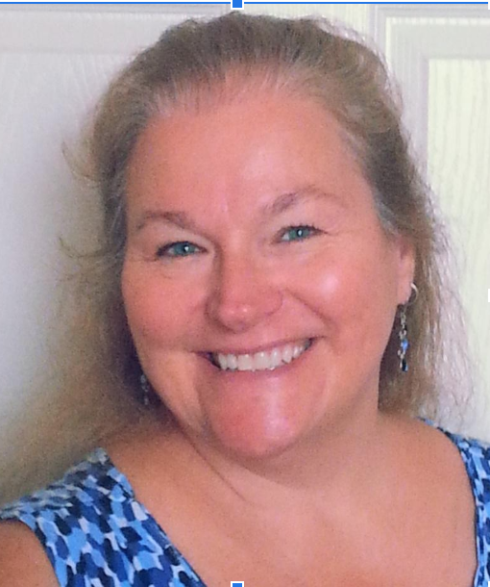
with local instructor Susan Kane

This mindful yoga class will include breath work, asanas (poses), partner and/or group poses, games or creative movement, relaxation/visualization. Children's literature is often incorporated into the class as well.
Susan is a retired elementary school teacher with 30+ years’ experience in the classroom. After retiring, she decided the next phase of her life would be devoted to spiritual endeavors. Thus, Susan’s business, InLight Transformation was born. At her office in Norway, Susan offers Reiki, Integrated Energy Therapy® and hypnosis services to her clients. She also teaches a variety of metaphysical classes through the year.
Susan enrolled in yoga teacher training and graduated in May of 2018 from the Tula Institute. That was just the beginning... She has continued her yoga education: ChildLight Yoga ®, Yoga and Mindfulness for Children in Dover, NH, Spring 2018; Certificate of Achievement in Movement in Stillness: A Restorative Yoga Immersion, October 2018; Curvy Yoga ® certification November 2018. Susan currently teaches weekly classes at Oxford School Age Child Care in Oxford, Posabilities Yoga Studio in Norway, and at Good Health is a Habit Fitness Studio in Waterford.

2019-2020 Winter Session
December 4-February 19 (10 week session)
Cost $450

Forest Friday Add-on Option Dates:
12/20, 1/24, and 2/21
Wednesdays and 1 Forest Friday $495
Wednesdays and 2 Forest Fridays $540
Wednesdays and all 3 Forest Fridays $570 (best deal!)

To register and for more information, please call 743-9700 to speak with Seal Rossignol or Amanda Killer OR email us at boxberryschool@gmail.com

